**SDA**

**Assignment #04**



**Instructor**

Zeeshan Ramzan

**Submitted by**

Abdul Haseeb Siddiqui

2021-SE-22

**Department of Computer Science,**

University of Engineering and Technology, Lahore, New-Campus.

28th February 2023

**Activity Diagrams**

1) Login

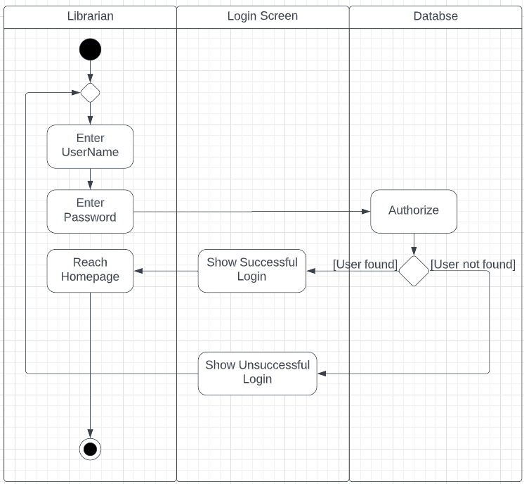

2) Authentication()

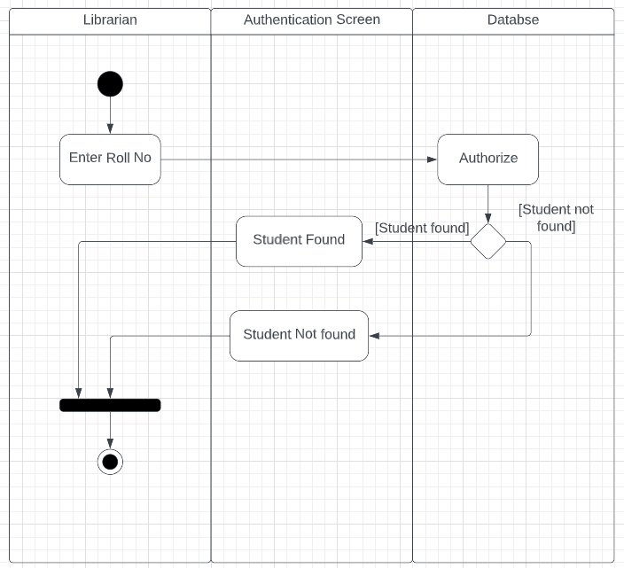

3) AddBook()

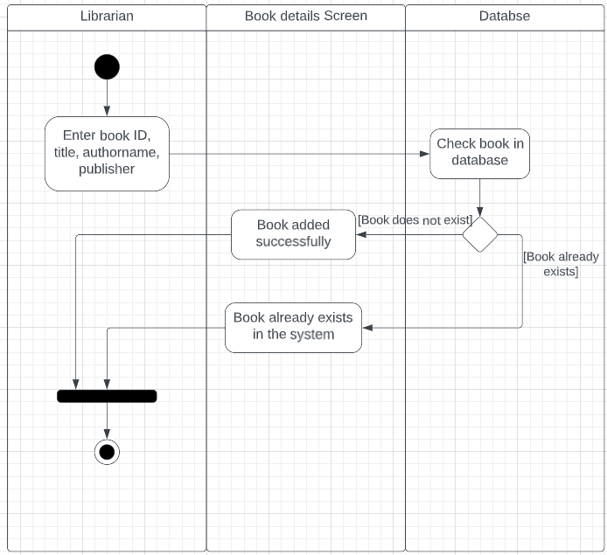

4)RemoveBook()

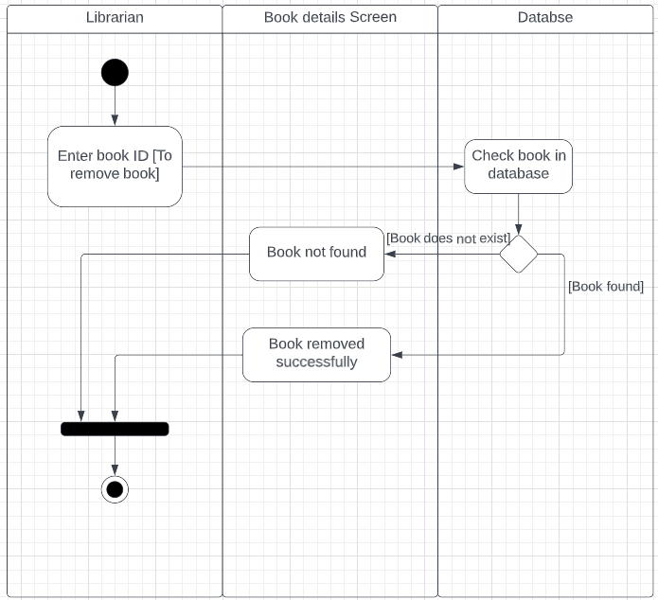

5)PayFine(), CollectFine()

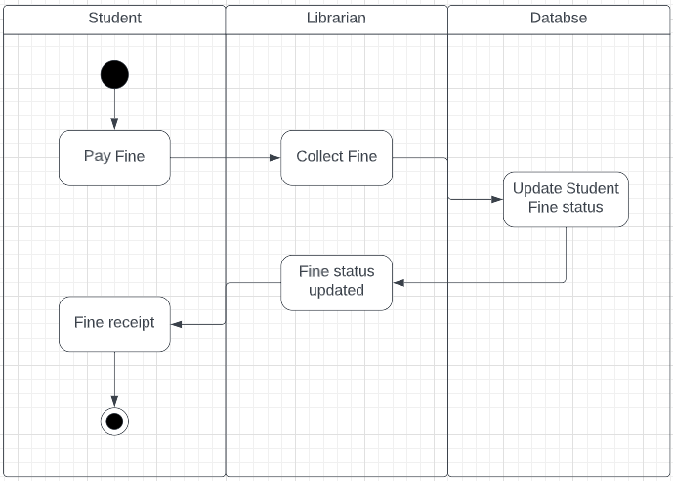

6)SearchBook(ID)

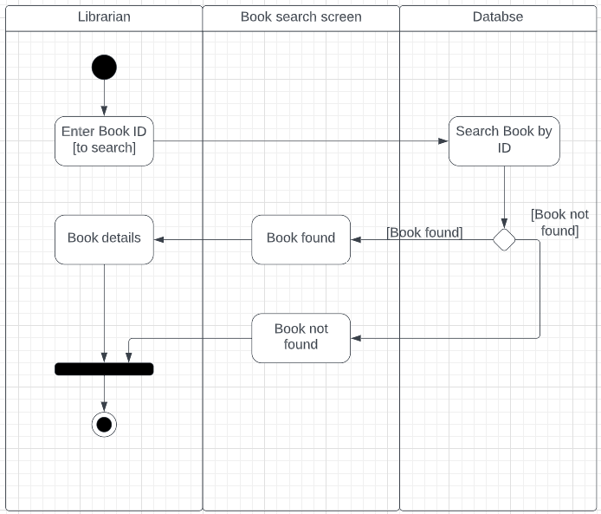

7) SearchBook(title)

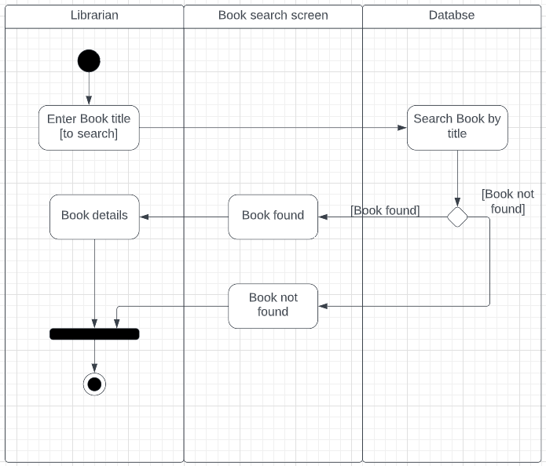

8) SearchBook(authorName)

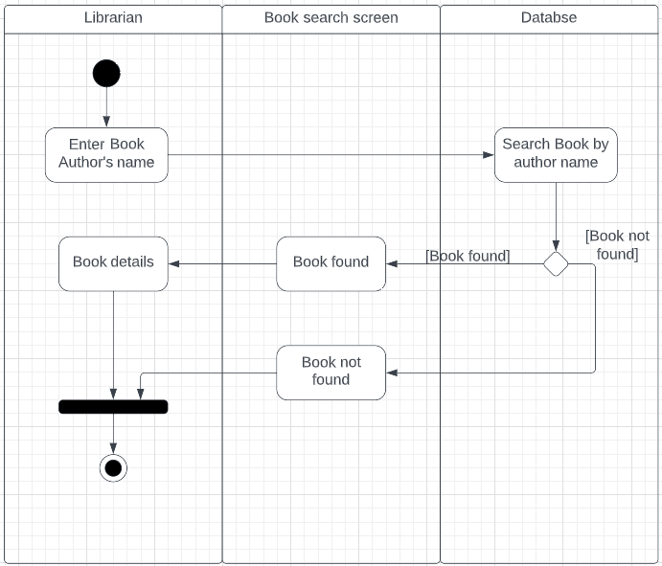

9) SearchBook(publisher)

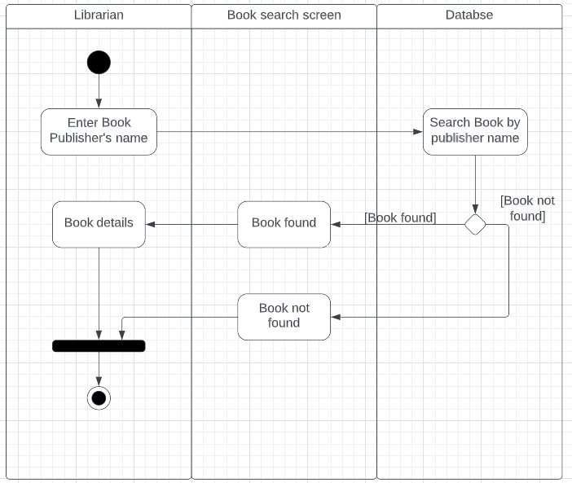

10) IssueBook() [Librarian]

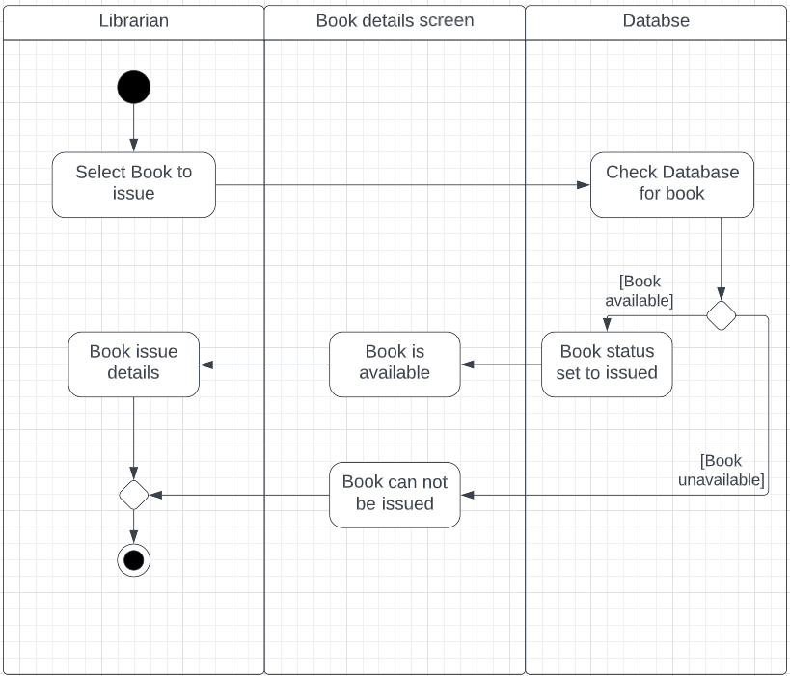

11)IssueBook() [Student, Teacher]

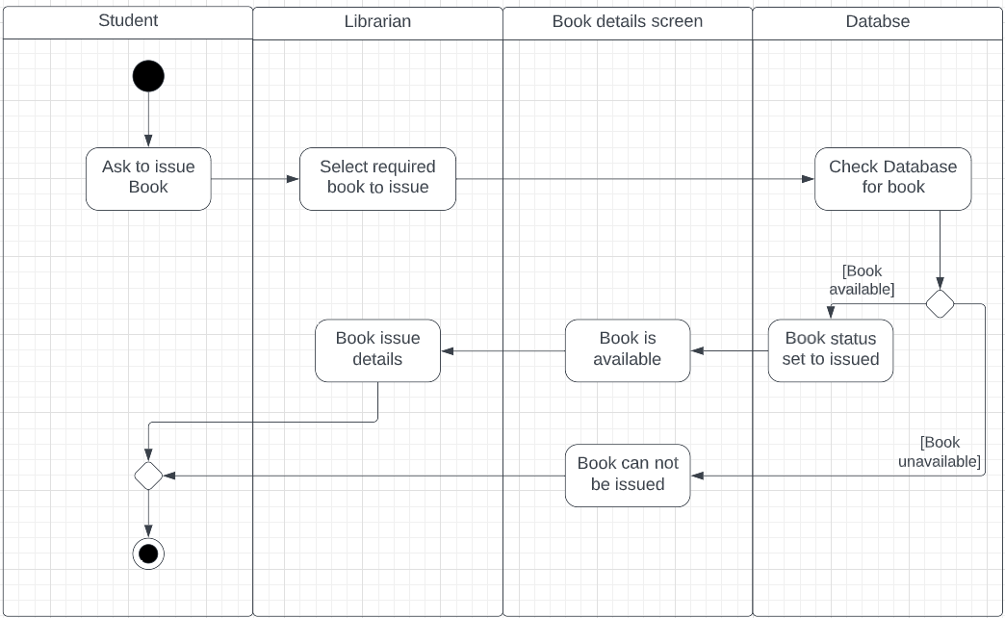

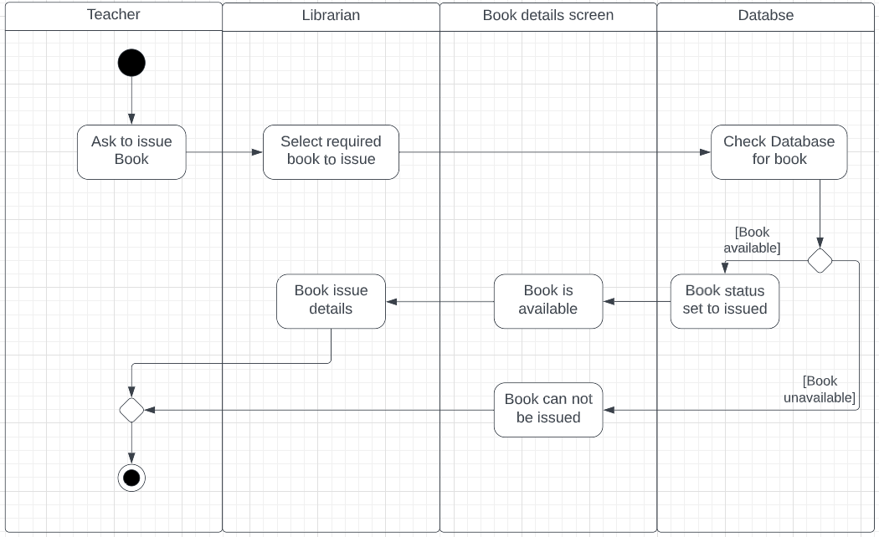

12) ReturnBook() [Teacher]

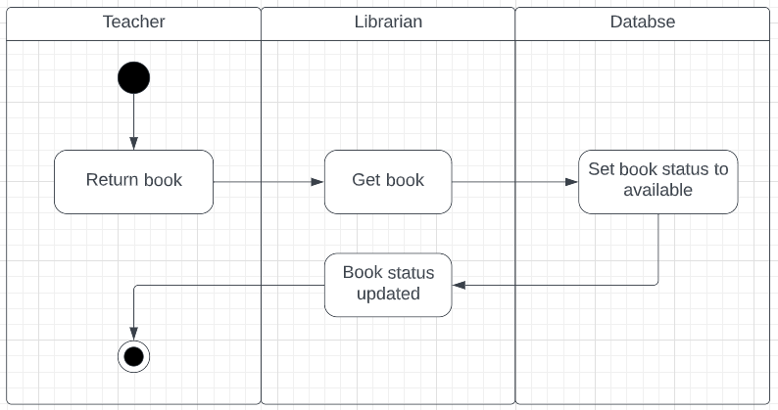

13) ReturnBook() [Student]

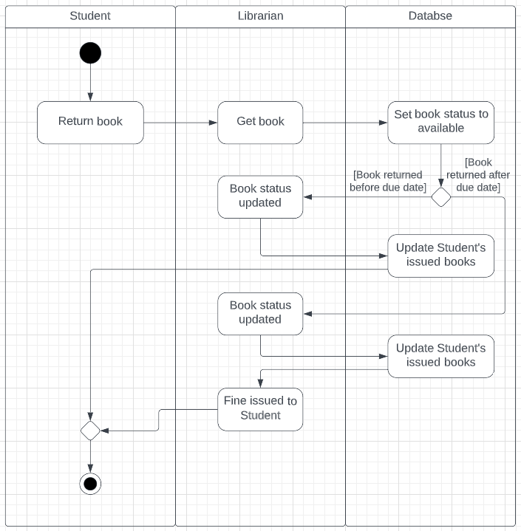

14) RenewBook() [Student]

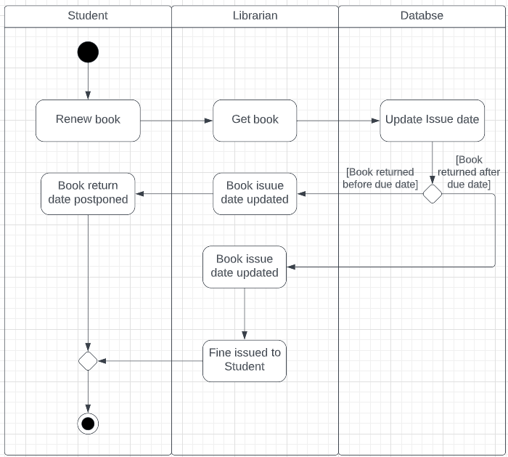

15) RenewBook() [Teacher]

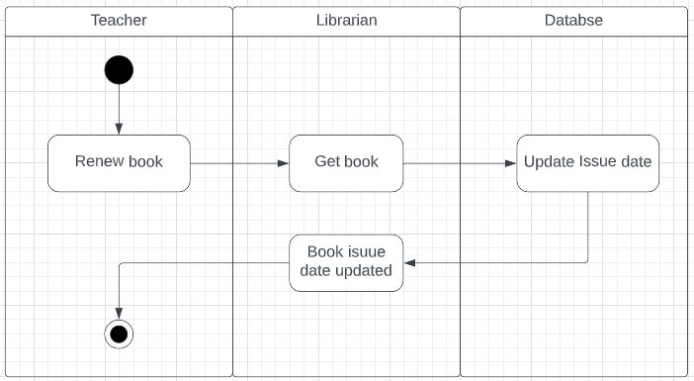

**State Machine Diagrams**

1)Login

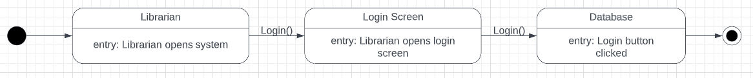

2)Authentication()

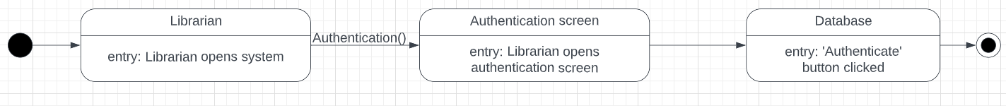

3) AddBook()



4) RemoveBook()



5) PayFine(), CollectFine()



6)SearchBook(ID)



7) SearchBook(title)



8) SearchBook(authorName)



9) SearchBook(publisher)



10) IssueBook() [Librarian]



11)IssueBook() [Student, Teacher]





12) ReturnBook() [Teacher]

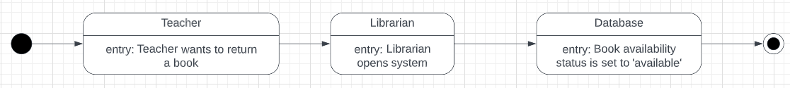

13) ReturnBook() [Student]

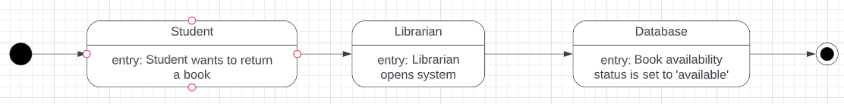

14) RenewBook() [Student]

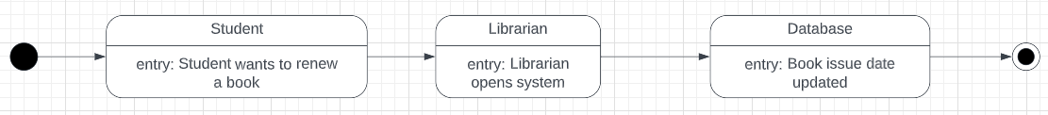

15) RenewBook() [Teacher]

